🌼 1️⃣ Default Prototype of main()
The JVM always looks for this exact method:
public static void main(String[] args)
This is called the regular signature of the main method.

🌼 2️⃣ Order of Modifiers
The order of public and static does not matter.
These are all valid:
public static void main(String[] args)
static public void main(String[] args)
Java allows modifiers to be interchanged.

🌼 3️⃣ Variants of Writing String Array
Arrays in Java support multiple syntaxes.
All three are correct:
public static void main(String[] args)
public static void main(String []args)
public static void main(String args[])
JVM treats all of them the same.

🌼 4️⃣ You Can Use Any Identifier Instead of args
args is not a keyword, it is just a normal variable name (identifier).
So you can replace it with any legal Java name:
public static void main(String[] HelloWorld)
public static void main(String[] myValues)
public static void main(String[] input)
All are valid because only the type and method signature matter to the JVM, not the variable name.

What are command-line arguments?
They are values passed to the program when you run it from the terminal.
Eg: Command_Line_Arguments _Eg1

java Command_Line_Arguments_1 Hello World
Here:
Hello → goes into args[0]
World → goes into args[1]

✔ 2. Role of String[] args
args is an array of strings.
Java stores command-line inputs in this array.
args.length → number of arguments given
args[0] → first argument
args[1] → second argument

✔ 3. Why do we check args.length < 2?
If we try to access:
args[0]
args[1]
but the user did not provide 2 arguments,
Java will throw:

ArrayIndexOutOfBoundsException
So we check:

if (args.length < 2)
to avoid the error.

✔ 4. What happens inside the if block?
System.out.println("Please provide at least 2 arguments!");
return;
A message is printed
return exits the entire main() method
Program stops safely
Remaining lines are not executed

✔ 5. If enough arguments are provided
Example:
java Command_Line_Arguments_1 Java Python
Then:
System.out.println(args[0]); // Java
System.out.println(args[1]); // Python
Program prints both values.

Here is the same explanation using simple English, keeping all the original details and depth.
In Java, the return keyword acts exactly like an exit door for a method (a block of code that performs a specific task).
When the computer sees the word return, two things happen immediately:
- Stop: The method stops running right there. No code after that line is executed.
- Go Back: Control goes back to the part of the code that called (triggered) this method.
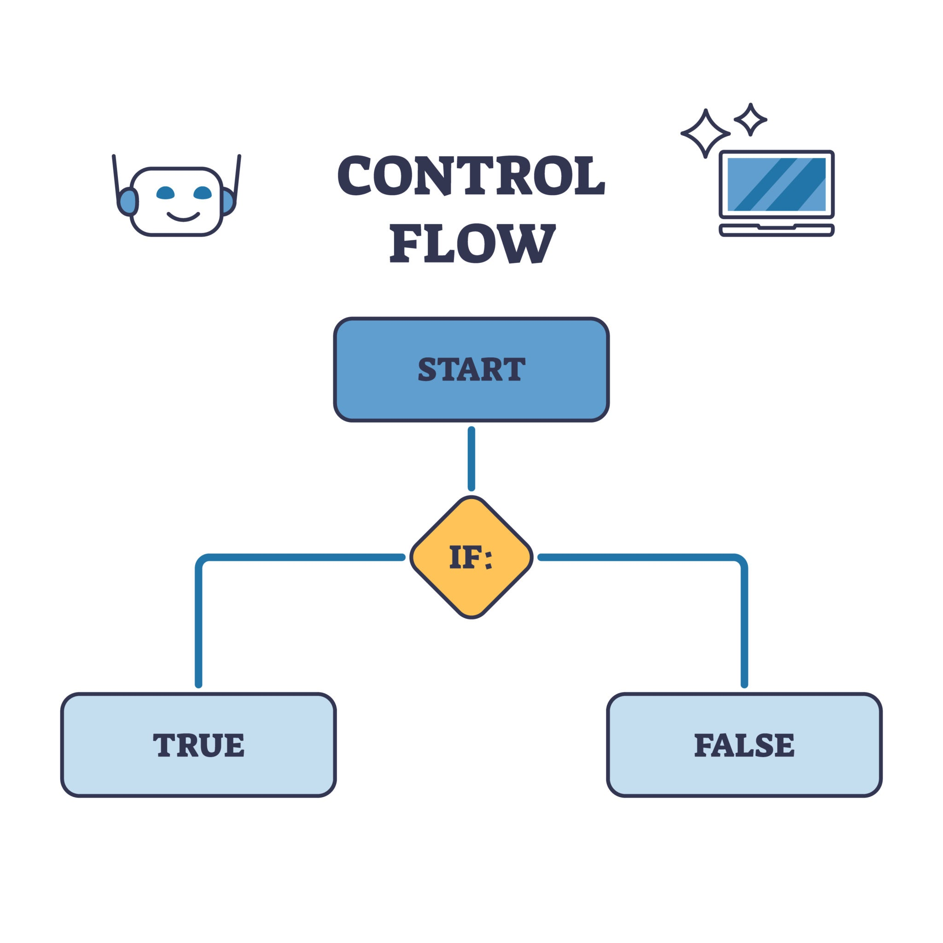
Getty Images
Here is a breakdown of how it works, depending on what kind of method you are writing.

1. Returning a Value (The "Delivery" Service)
Most often, you use a method to calculate something or get information. When the method finishes, it must give the result back to whoever asked for it.
Think of this like ordering a pizza. You call the pizza shop (the method). They do the work (cook). Then, they return the pizza to you.
- The Rule: If your method definition says it produces a specific type of data (like an int, String, or boolean), you must use the return keyword followed by that data.
Example:
Java
// This method promises to give back an integer (int)
public int addNumbers(int a, int b) {
int sum = a + b;
return sum; // Hand over the result. The method ends here.
}

public static void main(String[] args) {
// We call the method, and the "return" value is stored in 'result'
int result = addNumbers(5, 10);
System.out.println(result); // Prints 15
}

2. Void Methods (The "Do It and Stop" Service)
Sometimes, you want a method to just do something (like print a message or save a file) without giving back a specific number or text. These methods use the keyword void.
- The Rule: In a void method, you do not need to return a value. The method usually ends automatically when it reaches the closing curly brace }.
- Optional Use: You can still use return; (without a value) to exit the method early, perhaps if an error occurs.
Example:
Java
public void checkAge(int age) {
if (age < 18) {
System.out.println("Access Denied.");
return; // STOP HERE. Go back. Do not run the code below.
}

// This part only runs if the return above was not hit
System.out.println("Access Granted. Welcome!");
}

3. Critical Rules to Remember
To maintain depth in your code, you must understand these three constraints regarding return:

A. The "Unreachable Code" Error
Because return exits the method immediately, you cannot write code directly after it in the same block. The computer knows that code can never be reached, so it will give you an error.
Bad Code:
Java
return 5;
System.out.println("Hello"); // Error! This line is unreachable.

Why is it a Compile Time Error?
The Java Compiler (the tool that converts your code into a format the computer understands) is very smart. It analyzes the "flow" of your code before the program ever runs.
- It reads the line return 5; and understands: "Okay, the method ends here."
- It then looks at the next line: System.out.println("Hello");.
- It realizes: "Wait, the method already ended. It is impossible for the computer to ever reach this line."
Because this is a logical mistake that the compiler can see immediately, it refuses to build the program. It will give you an error message that looks like this: error: unreachable statement

B. The "Data Type" Match
The value you return must match the type you promised in the method name.
- If you promised an int (integer), you cannot return "Hello" (a String).
- If you promised a Dog object, you cannot return a Cat object.

C. The "All Paths" Rule
If your method promises to return a value, every possible scenario inside that method must lead to a return statement. You cannot leave the computer hanging.
Example of the "All Paths" logic:
Java
public boolean isEven(int number) {
if (number % 2 == 0) {
return true;
}
// If we stopped here, Java would complain.
// What happens if the number is NOT even?
// We must provide a return for the "else" scenario too.

return false;
}

Eg: Command_Line_Arguments_Eg2

🌼 Notes for the Command-Line Arguments Example

✔ 1. Command-line arguments start from index 0
Java arrays begin at index 0, so:
- 1st argument → args[0]
- 2nd argument → args[1]
- 3rd argument → args[2]
- 4th argument → args[3]
Using args[1], args[2], args[3] means the program expects four inputs.

✔ 2. The code requires at least 4 arguments
Since the code uses:
args[1];
args[2];
args[3];
the program must be run like:
java Command_Line_Arguments_2 A B C D
If fewer arguments are given, the program will throw:
ArrayIndexOutOfBoundsException
This shows what happens when indexes are used without checking args.length.

🌼 ArrayIndexOutOfBoundsException → Runtime Error

✔ The program compiles successfully
Java compiler does not check whether the array index is valid.
Example:
System.out.println(args[5]);
This compiles without any problem.

✔ Error occurs only when the program runs
If the array does not have index 5, then at execution time you get:
Exception in thread "main" java.lang.ArrayIndexOutOfBoundsException

Eg: Command_Line_Arguments_Eg3

1. Command-line arguments are passed ONLY at runtime
Yes.
When you run:
java MyClass A B C
Only at this moment JVM creates the args array.

2. The size of args[] depends ONLY on how many values you give at runtime
Example:
java MyClass A B C
Then:
args.length = 3
args[0] = "A"
args[1] = "B"
args[2] = "C"
Java decides the size based on your input.

3. ✅ 1. You cannot change the size of the args array
Correct.
You CANNOT do this:
args = new String[5]; // ❌ cannot recreate or resize args
Because:
- JVM already created the array
- JVM already decided its size
- JVM passed it to your program
- You can only use that array, not recreate it

✅ 2. You can only modify existing elements
If you run:
java Test hello world
Then args contains:
args[0] = "hello"
args[1] = "world"
args.length = 2
You can safely do:
args[1] = "day"; // ✔ valid because index 1 exists
But you CANNOT do:
args[2] = "night"; // ❌ index out of bounds (no index 2)

Eg: Command_Line_Arguments_Eg4

You need double quotes ONLY in special cases.
Let me explain clearly.

⭐ 1. If your argument has NO spaces → No double quotes needed
Example:
java Test hello world Java123
This becomes:
args[0] = "hello"
args[1] = "world"
args[2] = "Java123"
So no quotes needed.

⭐ 2. If your argument HAS spaces → You MUST use double quotes
Example:
java Test "hello world"
Now:
args[0] = "hello world"
Without quotes:
java Test hello world
Then:
args[0] = "hello"
args[1] = "world"
So double quotes group words together as one argument.

⭐ 3. If you want to include special characters
Examples:
java Test "@#$%"
java Test "hello*world"
Quotes make sure shell treats these characters as text, not commands.

⭐ Summary (Very Simple English)
Situation | Use Quotes? | Example
Single word | ❌ No | java Test hello
Multi-word (contains spaces) | ✔ Yes | java Test "hello world"
Special characters | ✔ Yes | java Test "*hello*"

